Project sponsor: Mike Zampini & Fredrik Borjesson
Project Title: Highway Worker Safety System
Abstract:
VZ-Cone, a leader in highway worker safety solutions, is dedicated to developing a product that not only alerts workers to potential hazards but also thrives under various environmental challenges. This focus is essential for enhancing safety in the busy realms of highway construction, aiming to significantly cut down on accidents and bolster work zone security.
The company's requirements were meticulously identified through interviews with sponsors and a thorough analysis of past project designs. It was established that weather resistance, high visibility, robust radio connectivity, and durable construction are crucial for meeting these needs. Additionally, the need for a product capable of emitting horizontal light, maintaining strong radio links, and delivering clear auditory warnings led to the decision that the product's mission would be to improve workplace safety through an integrated system combining a topper and a boombox. This system would effectively notify both workers and approaching traffic about potential dangers.
Several concepts were explored and evaluated, as detailed in this report. The chosen solution was a modular design that includes a topper with extensive horizontal light coverage and a boombox with a powerful audio system. Further information on concept selection and product architecture is provided.
Functionality hinges on durability, portability, and the audibility of the horn. Our engineering analysis demonstrates how the design was optimized for extreme weather conditions, varying traffic scenarios, and different operational settings. Material strength, weight distribution, and sound amplification have all been tailored to withstand high humidity, fluctuating temperatures, and extended use.
The design also prioritizes cost-effectiveness, visibility, and energy efficiency. Innovations include selective material use, reflective enhancements, and power management optimizations.
Prototype testing encompassed stress testing, visibility range evaluation, and audio clarity checks under a range of conditions from calm weather to simulated storms.
An economic analysis suggests that with an initial investment of $1,200, VZ-Cone expects to either recoup costs within 24 months, boost productivity by 30%, or reduce unit costs to $75, underscoring the project’s financial viability and potential impact on operational efficiency.
Final Product:
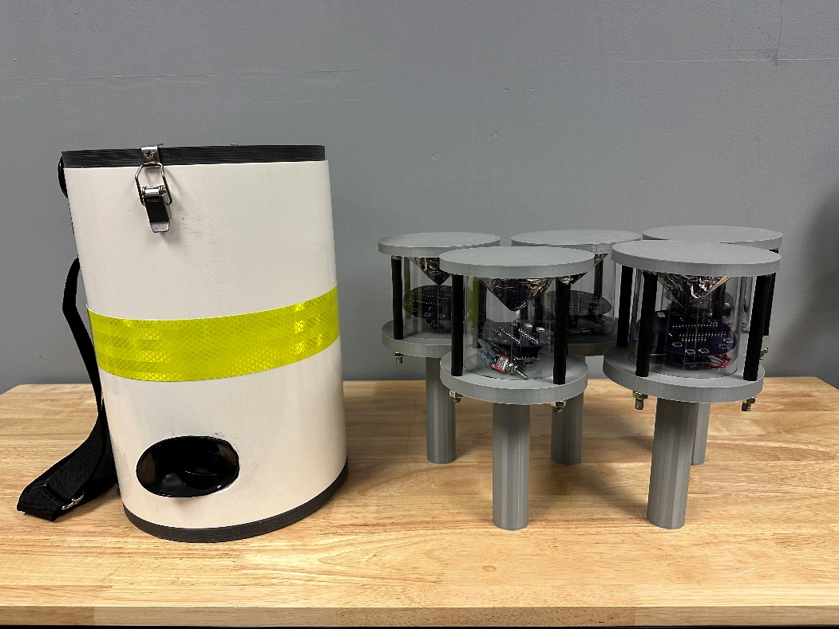
Student Team:
